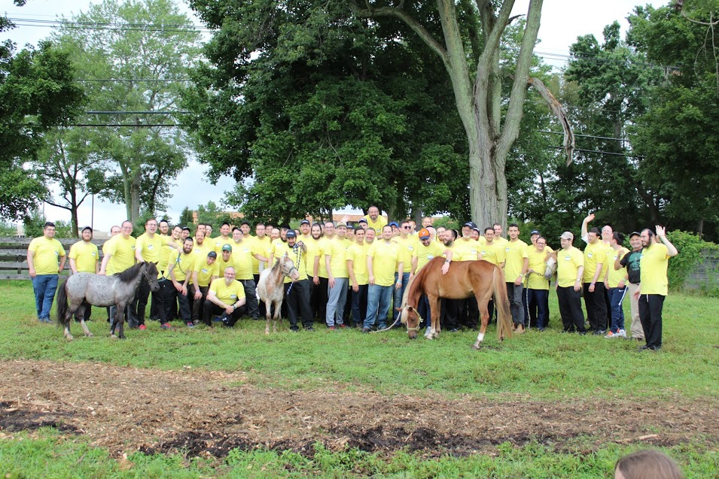
CORPORATE PARTIES AND EVENTS

TEAM BUILDING, TEAM BONDING, TRAIL RIDES,
COMPANY PICNICS AND FUN OUTINGS
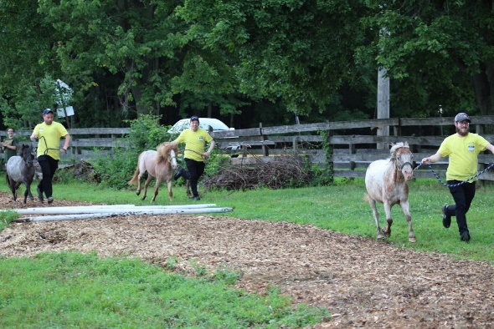
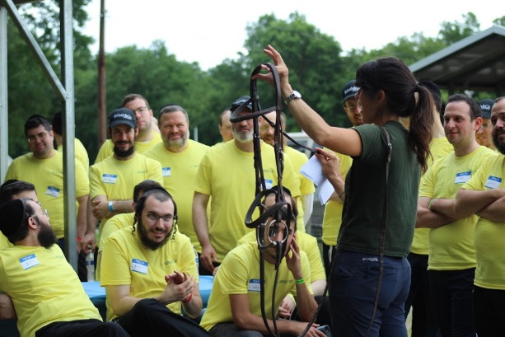
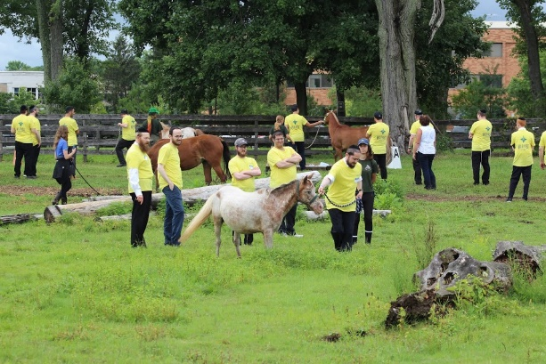

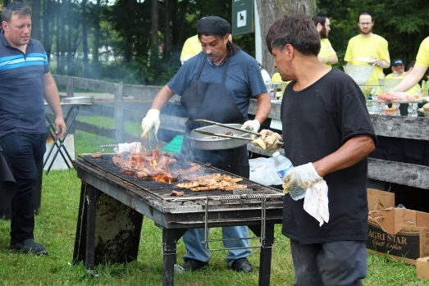
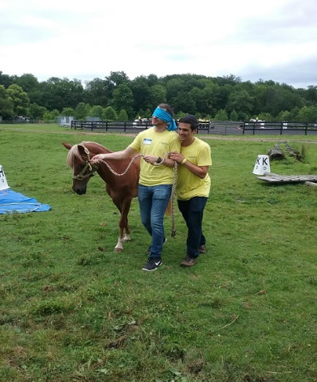
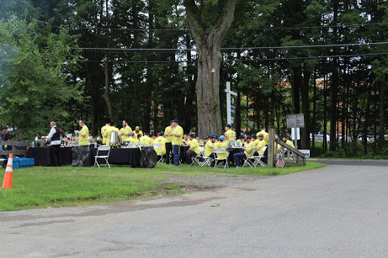

Seaton Hackney Stables
440 South Street, Morristown, NJ 07960
(973) 644-3355 Seatonh@verizon.net
Come visit us: we’ll love to show you around!

If you are considering a Team Building experience, a Corporate party, a Team Bonding outing or a simple Trail Ride, our dedicated staff will customize your event to suit it to your specific objectives. Your guests -as few as 6 or as many as 60- are guaranteed an exceptional and fun-filled experience resulting in a more engaged, cohesive and productive team.
Call (973)644-3355 or email Seatonh@verizon.net to discuss options, some even priced
below the cost of just a riding lesson!

